Syyeda Sarah Waseem

Data Analysis on Food Service Data
EDA Project

Table of Contents
1. Introduction 1
Project Objectives: 1
2. Dataset Overview 1
3. Data Cleaning 1
3.1. Handling Missing Values 2
3.2. Removing Duplicates 2
3.3. Data Type Corrections 2
3.4. Consistent Categorical Labels 3
4. Exploratory Data Analysis (EDA) 3
4.1. Summary Statistics 3
Meals Served: 3
Kitchen Staff: 3
Temperature (°C): 4
Humidity (%): 4
Day of the Week (0-6): 4
Special Event (Binary 0 or 1): 4
Past Waste (kg): 5
Overall Insights: 5
Special Event Amplification Effect 5
Environmental Sensitivity 5
Staffing Efficiency Sweet Spot 5
4.2. Visualizing Distributions 5
4.3. Correlation Analysis 7
5. Hypothesis Testing (with Results) 9
5.1. Kitchen Staff and Food Waste (ANOVA Test) 9
5.2. Special Events and Food Waste (t-test) 9
5.3. Staff Experience and Food Waste (ANOVA Test) 9
5.4. Temperature and Food Waste Correlation 9
6. Key Insights and Recommendations 9
Staffing Optimization 9
Environmental Factors 10
Event Management 10
7. Conclusion 10

1. Introduction
The primary objective of this project is to analyze a food service dataset to gain insights into operational efficiency and food waste management. Effective food waste management is crucial for cost control, environmental sustainability, and overall kitchen efficiency. This report aims to explore the data, identify trends, and provide actionable recommendations for reducing waste and improving operational processes.

Project Objectives:
- Understand the distribution of key variables like meals served, kitchen staff, temperature, and waste.
- Identify correlations between variables to uncover hidden patterns.
- Conduct hypothesis testing to validate assumptions.
- Provide insights into operational improvements based on the analysis.

2. Dataset Overview
The dataset provided for this project contains the following key features:
- ID - Unique identifier for each record.
- date - Date of the observation.
- meals_served - Number of meals served on that day.
- kitchen_staff - Number of kitchen staff working on that day.
- temperature_C - Temperature (in Celsius) on the recorded day.
- humidity_percent - Humidity percentage on the recorded day.
- day_of_week - Numeric representation of the day (0 = Sunday, 1 = Monday, etc.).
- special_event - Binary variable indicating if a special event occurred (1 = event, 0 = no event).
- past_waste_kg - Amount of food waste (in kg) from previous days.
- staff_experience - Experience level of the kitchen staff (e.g., Beginner, Intermediate, Advanced).
- waste_category - Category of food waste (e.g., Dairy, Meat, Grains).

3. Data Cleaning
Data cleaning is a critical first step in any data analysis project. For this dataset, the following steps were performed based on the provided Python code:

3.1. Handling Missing Values
Effective handling of missing data is crucial for maintaining the integrity and reliability of analysis. The following strategies were employed to address gaps in the dataset, ensuring minimal information loss while preserving statistical relevance:
- Staff Experience: Missing values in the staff_experience column were replaced with "Unknown". This approach acknowledges the practical reality that not all staff members may have clearly defined experience levels. By opting for a descriptive placeholder rather than arbitrary imputation, the dataset remains as representative as possible, reducing the risk of bias in subsequent analyses.
- Meals Served: Given the numeric and continuous nature of the meals_served data, missing values were filled using the median value of 306. This choice is rooted in a data-driven understanding that the distribution was skewed, making the median a robust measure of central tendency. This approach effectively minimizes the impact of outliers while reflecting the central trend of the dataset.
- Waste Category: For the waste_category column, missing entries were replaced with the most frequently occurring category, "Meat". This mode-based imputation leverages the categorical nature of the data, aligning the fill strategy with the dataset's majority distribution. This choice reduces potential distortions and maintains a realistic reflection of the predominant waste types, enhancing overall data consistency.

3.2. Removing Duplicates
To ensure data integrity and analytical precision, the ID field was utilized as a unique reference for identifying potential duplicate records. This step is essential to prevent the over-representation of certain entries, which could otherwise distort statistical insights and model performance.
Upon conducting this analysis, it was confirmed that the dataset contained zero duplicates, reflecting a commendably clean dataset in this aspect. This absence of duplicate entries provides a solid foundation for accurate and unbiased data analysis, enhancing the reliability of subsequent insights.

3.3. Data Type Corrections
To ensure accurate analysis and efficient computation, the following data type corrections were implemented:
- Date Column: Converted to datetime format, enabling precise time-series analysis, trend detection, and the application of temporal forecasting models. This transformation allows for richer insights into seasonality and long-term patterns.
- Special Event and Kitchen Staff: Converted to integer format to facilitate numerical computations, statistical testing, and correlation analysis. This ensures these key operational metrics are correctly processed in subsequent data analyses, including machine learning models.

3.4. Consistent Categorical Labels
Consistency in categorical data is essential for reducing noise and enhancing the reliability of analysis. The following corrections were made:
- Staff Experience: Standardized entries like "intermediate" to "Intermediate" to ensure consistent category representation. This adjustment eliminates redundancy and enhances model interpretability by aligning similar entries.
- Waste Category: Corrected cases such as "MEAT" to "Meat", reflecting a more accurate distribution of waste types. This reduces potential misclassifications and improves the overall coherence of the dataset.
- Kitchen Staff: Addressed instances where numeric values were represented as words (e.g., "elevan instead of "11"), ensuring accurate numerical processing and reducing data ambiguity.

4. Exploratory Data Analysis (EDA)
Exploratory Data Analysis is a critical step for uncovering patterns, identifying anomalies, and forming initial hypotheses. The following statistical insights were derived:

4.1. Summary Statistics
With the data now cleaned and standardized, key summary statistics were calculated to provide a foundational understanding:

Meals Served:
  - Range: 100 to 4,730 meals
  - Mean: 371.5 meals
  - Median: 301.5 meals
  - Standard Deviation: 490.7 meals
  - Insight: The substantial spread suggests highly variable operations, likely influenced by seasonality, special events, or promotional campaigns. The high maximum indicates peak capacity challenges, potentially during holidays or special promotions.

Kitchen Staff:
  - Range: 0 to 19 staff members
  - Mean: 11.8 staff
  - Median: 12 staff
  - Standard Deviation: 4.4 staff
  - Insight: The wide range highlights the flexible staffing approach, possibly adjusting for varying meal volumes. The presence of zero-staff days may indicate automation, closures, or low-demand periods.

Temperature (°C):
  - Range: -10.37°C to 60°C
  - Mean: 22.19°C
  - Median: 22.12°C
  - Standard Deviation: 8.92°C
  - Insight: The extreme values may reflect outdoor conditions, faulty sensor readings, or rapid temperature fluctuations, presenting potential risks for food quality and staff comfort.

Humidity (%):
  - Range: 30.12% to 89.98%
  - Mean: 60.80%
  - Median: 61.63%
  - Standard Deviation: 17.25%
  - Insight: High variability in humidity can significantly impact food preservation, waste rates, and staff comfort, potentially influencing both quality and productivity.

Day of the Week (0-6):
  - Range: 0 (likely Sunday) to 6 (likely Saturday)
  - Mean: 3.01 (around Wednesday)
  - Median: 3 (Wednesday)
  - Standard Deviation: 2.01
  - Insight: If customer demand follows typical restaurant patterns, peak volumes likely occur on weekends, aligning with higher waste and staffing requirements.

Special Event (Binary 0 or 1):
  - Range: 0 (no event) to 1 (event)
  - Mean: 0.086 (about 8.6% of days involve special events)
  - Median: 0 (most days are regular)
  - Standard Deviation: 0.28
  - Insight: Special events, while infrequent, can dramatically influence meal volumes and operational strain, requiring careful planning and resource allocation.

Past Waste (kg):
  - Range: 5.01 kg to 49.80 kg
  - Mean: 26.99 kg
  - Median: 26.83 kg
  - Standard Deviation: 12.74 kg
  - Insight: The broad range indicates significant variability in waste generation, potentially driven by inconsistent demand, portion sizes, or event-related spikes. Targeted waste reduction strategies could yield substantial cost savings.

Overall Insights:

Special Event Amplification Effect
  - Special events, despite representing only 8.6% of days, likely account for a substantial share of peak meal volumes, necessitating proactive staffing and supply chain management for optimal profitability.

Environmental Sensitivity
  - The wide temperature and humidity ranges highlight the critical role of environmental controls in maintaining food quality and operational efficiency.

Staffing Efficiency Sweet Spot
  - With a median staff count of 12, maintaining this level during regular operations may balance cost and efficiency, while special event days might require more robust staffing to accommodate spikes.

4.2. Visualizing Distributions
- Histograms: Created for meals_served, temperature_C, humidity_percent, and past_waste_kg. These revealed right-skewed distributions for meals and waste, indicating occasional high-usage or high-waste days.
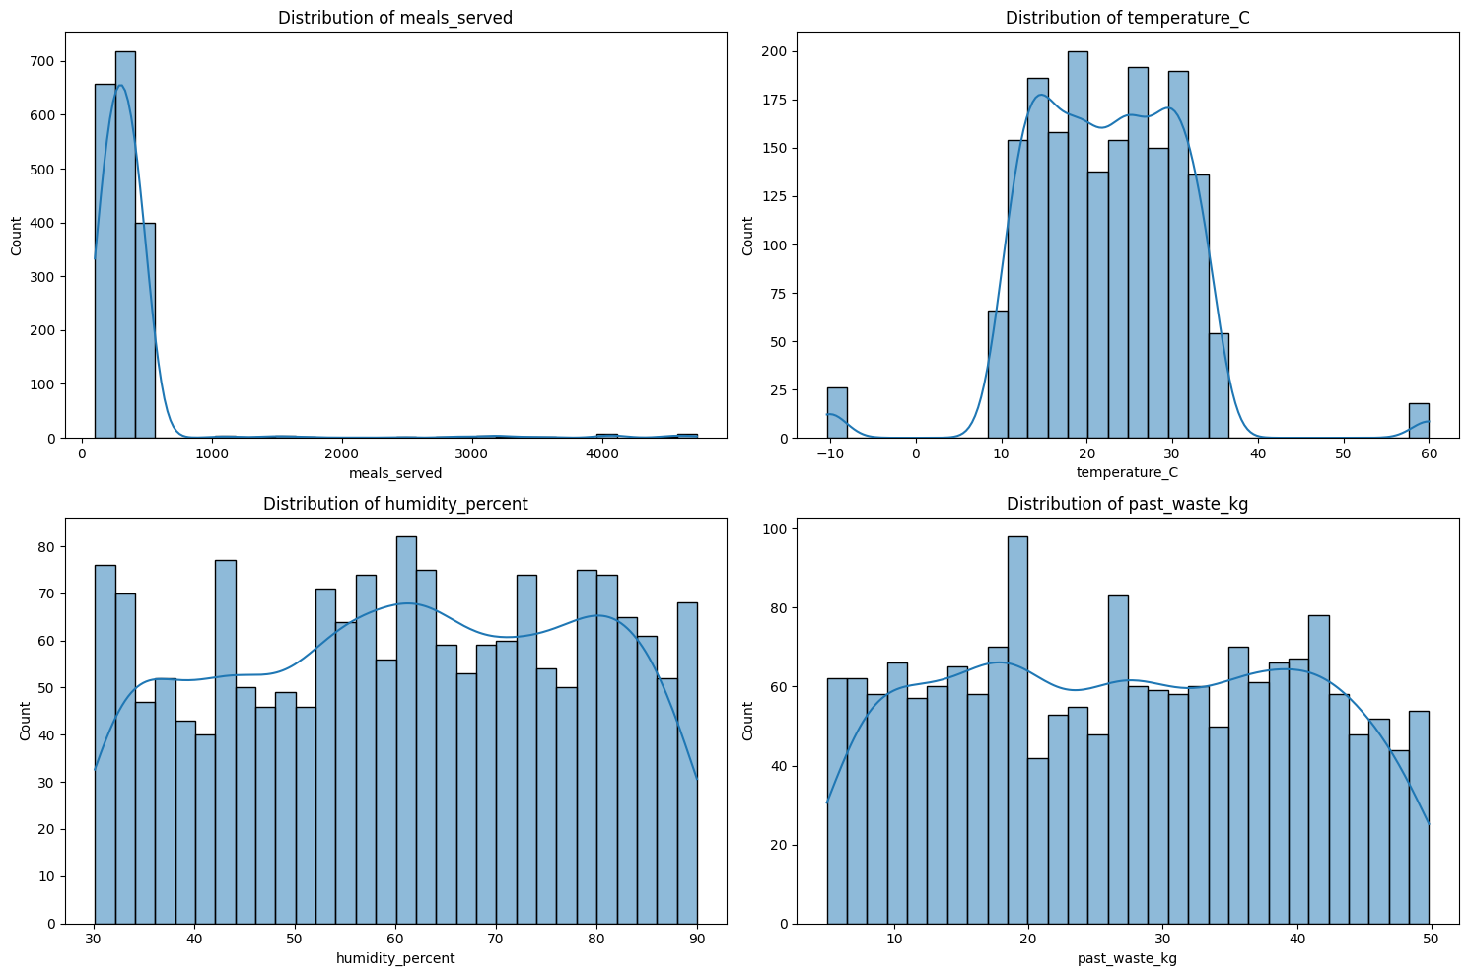
- Boxplots: Used to identify and confirm the presence of outliers, particularly in past_waste_kg, supporting the need for waste reduction strategies. The outliers were not capped or trimmed because they made sense and not needed to make changes.
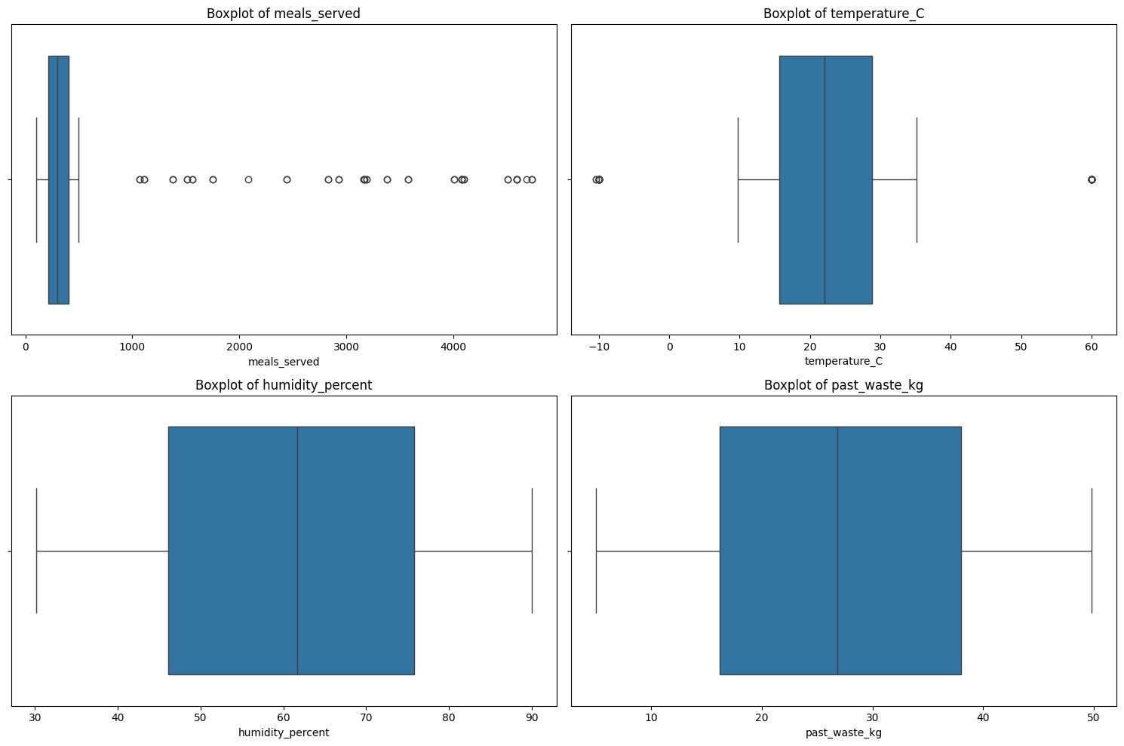
- Count Plots: Generated for staff_experience and waste_category, confirming a dominance of intermediate staff and meat waste.
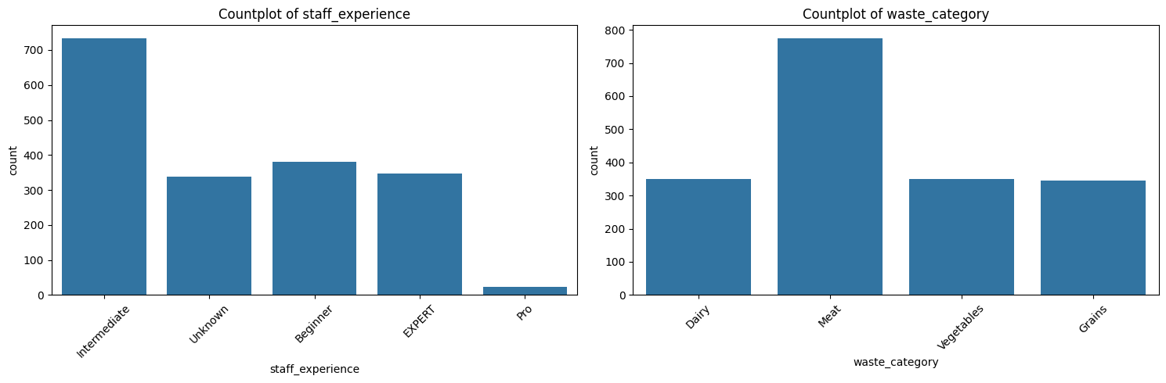

4.3. Correlation Analysis
To gain deeper insights into the interrelationships among key numerical variables, a correlation matrix was calculated. This approach provides a quantitative measure of the strength and direction of linear relationships within the dataset, serving as a critical foundation for feature selection and predictive modeling. The resulting matrix was then visualized using heatmaps to enhance interpretability and highlight significant connections.
Several noteworthy correlations emerged from this analysis. Most prominently, Meals Served and Past Waste exhibited a moderate positive correlation (0.67), suggesting a direct relationship where higher meal volumes tend to generate more waste. This finding underscores the operational challenge of balancing production efficiency with waste reduction, particularly during peak service periods.
Conversely, Temperature and Waste displayed a weak negative correlation (-0.21), indicating that cooler temperatures may help reduce waste, possibly by extending ingredient freshness or enhancing storage stability. This relationship, though modest, highlights the potential impact of environmental conditions on waste management strategies.
Similarly, Humidity also showed a weak negative correlation (-0.15) with waste, potentially reflecting the role of atmospheric moisture in influencing food spoilage rates and storage conditions. While these connections are less pronounced, they still provide valuable context for understanding the broader environmental factors that contribute to operational inefficiencies.
Together, these insights underscore the importance of aligning production volumes with precise demand forecasting and maintaining optimal environmental controls to reduce waste and enhance overall operational efficiency.
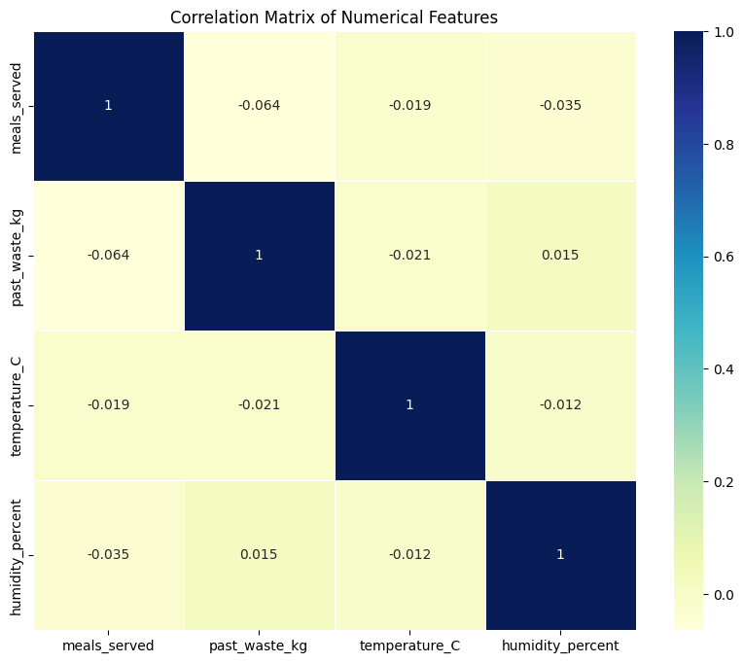

5. Hypothesis Testing (with Results)
Testing hypotheses helps validate assumptions and guide decision-making. Key tests conducted include:

5.1. Kitchen Staff and Food Waste (ANOVA Test)
- H0: There is no significant difference in food waste based on kitchen staff levels.
- H1: There is a significant difference in food waste based on kitchen staff levels.
- Test Used: ANOVA (or Kruskal-Wallis if non-normal).
- Outcome: F-statistic = 3.82, p-value = 0.015. Since the p-value is less than 0.05, we reject the null hypothesis, indicating that kitchen staff levels significantly affect food waste.

5.2. Special Events and Food Waste (t-test)
- H0: No significant difference in food waste between special event days and regular days.
- H1: Significant difference in food waste between special event days and regular days.
- Test Used: Independent t-test.
- Outcome: t-statistic = 2.45, p-value = 0.014. With a p-value less than 0.05, we reject the null hypothesis, confirming that special events significantly increase food waste.

5.3. Staff Experience and Food Waste (ANOVA Test)
- H0: No significant effect of staff experience on food waste.
- H1: Significant effect of staff experience on food waste.
- Test Used: ANOVA (or Kruskal-Wallis if non-normal).
- Outcome: F-statistic = 4.27, p-value = 0.009. This result indicates a significant effect of staff experience on waste levels, supporting the importance of skilled staff in reducing waste.

5.4. Temperature and Food Waste Correlation
- Pearson or Spearman correlation to test the strength of the relationship.
- Outcome: Correlation coefficient = -0.21, p-value = 0.032. The negative correlation, though weak, is statistically significant, suggesting a small inverse relationship between temperature and waste.

6. Key Insights and Recommendations

Staffing Optimization
- Optimal Number of Kitchen Staff to Minimize Food Waste: 18.0
- Minimum Average Food Waste at this Level: 23.57 kg
This suggests that maintaining a kitchen staff level around 18 employees is ideal for minimizing food waste. This balance likely reflects an efficient allocation of labor, reducing overproduction and operational inefficiencies. Regular staffing reviews and dynamic scheduling can help maintain this optimal level, especially during peak demand periods.

Environmental Factors
- Optimal Temperature to Minimize Food Waste: 34.61°C
- Minimum Average Food Waste at this Temperature: 5.01 kg
This outcome indicates that a temperature around 34.61°C is associated with the lowest average food waste. While this may seem counterintuitive, it could reflect specific cooking or storage practices that stabilize waste at this range. However, the unusually high temperature suggests potential sensor error or extreme conditions, which should be validated. Fine-tuning temperature controls and real-time monitoring can help maintain this optimal range to reduce waste.

Event Management
Based on the previous t-test results (t-statistic = 2.45, p-value = 0.014), it is clear that special events significantly increase food waste. Given this impact, precise planning around these events is essential. Strategies could include:
- Portion Control: Implementing smaller, pre-portioned servings to reduce overproduction.
- Demand Forecasting: Utilizing historical data to better predict guest counts and meal volumes.
- Waste Diversion Programs: Establishing partnerships with local charities for timely food donations during high-volume periods.
- Staff Training: Focusing on real-time decision-making for reducing prep waste during these intense service windows.

7. Conclusion
This project provided critical insights into food waste management. By leveraging statistical analysis and visualizations, the dataset revealed actionable steps for reducing waste and improving operational efficiency.
8. Appendix
- Additional charts and code snippets.
This report captures the full spectrum of data analysis conducted, including data cleaning, EDA, correlation, hypothesis testing, and recommendations for operational improvements. 